Title | MVMeasurement Requirements Specification
Distribution | Software Archive
Author | Zuochen Wang |  | Date | 2015-06-24
Review | See Review Section |  | Date | See Review Section
Approved |  |  | Date
Approved |  |  | Date
Remarks | All Requirements will be implemented as defined in this document and tested accordingly.
Contents

1. Introduction 3
1.1. Scope 3
1.2. Definitions, acronyms, and abbreviations 3
1.3. Document conventions 4
2. Overall description 4
2.1. Use Case 4
2.2. Assumptions and dependencies 4
2.2.1. Assumptions 4
2.2.2. Dependencies 4
3. None Function Requirements 5
3.1. General Requirements 5
3.1.1. Language 5
3.1.2. Microcontroller 5
3.1.3. Optimization Requirement 5
3.1.4. Dynamic memory 5
3.1.5. Framework 5
3.1.6. Documentation 5
1. Document Review 6
2. Design 6
3. Code Review 6
4. Testing 6
3.2. Software Verification and Validation 6
3.2.1. Code review 6
3.2.2. Static code analysis 6
3.2.3. Module test 6
3.2.4. Integration Test Requirement 7
4. Functional Requirements 7
Measure biogas actual volume rate for methane at real condition. 8
Measure biogas standard volume rate for methane at standard condition. 8
Measure Steam Mass flow 8
Measure Steam Power Flow 8
Compute percentage of QMax for Standard Volume flow 9
Compute percentage of QMax for mass flow 9
Compute percentage of QMax for Power flow 10
5. Subsystem Documentation 10
6. References 10
7. Revision History 10

List of Figures
Figure 1 Communication Board Architecture 3
Figure 2 MVMeasurement Use Case Diagram 5

List of Tables
Table 1 Definitions 4
Table 2 Abbreviation 4

Introduction

Scope
This document is intended to specify the software requirements for the MVMeasurement Subsystem. The MVMeasurement is a part of VT5.
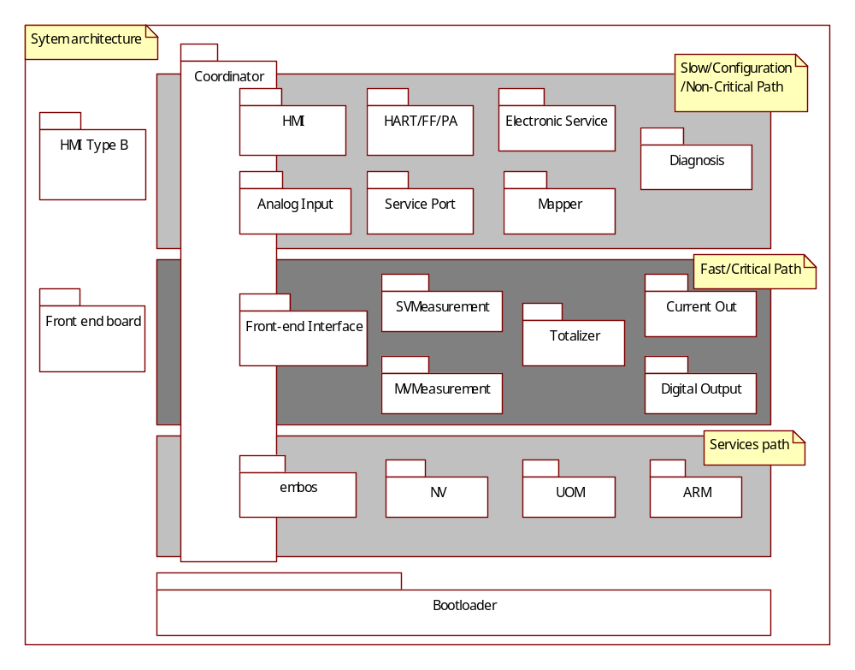
Figure 1 Communication Board Architecture

Definitions, acronyms, and abbreviations

Definitions
EmbOS | An embedded operating system for the development of real time application for a variety of microcontrollers.
EEPROM | Electrically Erasable Programmable Read-Only Memory.
ServicePort subsystem | VT5 subsystem for providing communications like HMI & HART for service engineer base on HMI connectors.
Mapper Subsystem | VT5 subsystem for mapping the device variable to HART dynamic variable
CurrentOut Subsystem | VT5 subsystem for setting current out value to output PV percent value.
FrontEndInterface Subsystem | VT5 subsystem for exchange data with Frontend board.
ElectronicService Subsystem | VT5 subsystem for providing RAM/ROM check, temperature/ push button check.
NV Subsystem | VT5 subsystem responsible for read / write access and maintenance of non-volatile memories (in transmitter and sensor).
Diagnostic Subsystem | VT5 subsystem responsible for handling error conditions and warnings. Also provides General Alarm data for the Digital Output subsystem.
HART Subsystem | VT5 subsystem for interfacing to HART (Highway Addressable Remote Transducer) protocol communications.
HMI Subsystem | VT5 subsystem providing Human Machine Interface for local user access via display and key input.
SVMeasurement | VT5 subsystem providing Single Variable Measurement, such as volume flow.
MVMeasurement | VT5 subsystem providing Multi-Variable Measurement, such as mass flow, energy flow and so on.
Totalizer Subsystem | VT5 subsystem providing calculation of accumulative total, such as volume, mass, energy and so on.
Digital Output subsystem | VT5 subsystem for setting frequency value to output PV percent value, or totalizer value, or alarm value
Bootloader | A boot program

Table 1 Definitions

Acronyms and abbreviations
Term | Definitions
CB | Communication Board
HART | Highway Addressable Remote Transducer
SIL | Safety Integrity Level
VT5 | Vortex5
HMI | Human Machine Interface
MCU | Microcontroller Unit
ROM | Read only memory
RAM | Random access memory
EEPROM | Electrically Erasable Programmable Read-Only Memory
NV | Non volatile
RTOS | Real time operation system
QMax | Upper range of flow
QMin | Lower fange of flow
TBD | To be determined
Table 2 Abbreviation

Document conventions
Software requirements are identified using the following in-line table format:
Ident. | Definition / Motivation | Priority | Source
 |  | Stability | Source
Each field is described in the following list:

Ident. a unique identifier for the Requirement
Priority one of: Mandatory / Desirable / Future
Stability one of: Committed (Agreed by approvers) / Not yet agreed / Likely to change

Overall description
It implements the flow rate calculation for the following operation mode:
- Biogas Volume flow
- Standard Volume flow of Liquid
- Normal Volume flow of Gas (ideal Gas & Real Gas)
- Biogas Normal Volume flow
- Mass flow for Liquid
- Mass flow for Gas
- Mass flow for Steam
- Energy flow for Liquid
- Energy flow for Gas
- Energy flow for Steam
The steam calculation will comply with the IAPWS-97 Standard and the Natural Gas Compress factor will use the AGA8 and GERG Standards (ISO12213) Standards.

Use Case
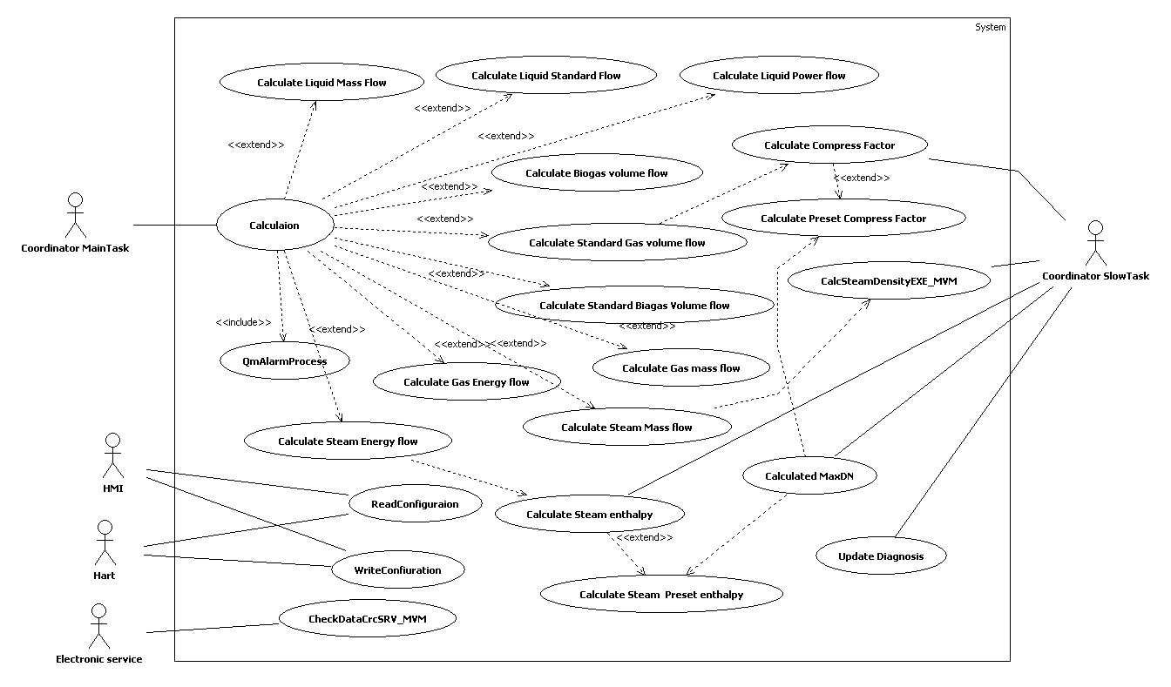

Figure 2 MVMeasurement Use Case Diagram

Assumptions and dependencies

Assumptions

Dependencies
Development and testing will be done regarding to the following conditions:
  - Compiler: IAR Compiler V3. 40
  - Framework: 2.3.1
  - Oscillator frequency: 3.6864 MHz
  - CPU clock is oscillator frequency / 2

None Function Requirements

General Requirements

Language
Ident. | Definition / Motivation | Priority  M | Source  [RS004] 3.1.1
NFR3.1.1 | The software shall be written in “C” language. Or Assembler Language | Stability  C | Source  [RS004] 3.1.1

Microcontroller
Ident. | Definition / Motivation | Priority  M | Source  [RS004] 3.1.2
NFR3.1.2 | The MCU is RENESAS M16C/63 | Stability  C | Source  [RS004] 3.1.2

Optimization Requirement
Ident. | Definition / Motivation | Priority  M | Source  R&D
NFR3.1.3 | No compiler optimizations are permitted | Stability  C | Source  R&D

Dynamic memory
Ident. | Definition / Motivation | Priority  M | Source  [RS004] 3.3.1
NFR3.1.4 | Dynamic memory allocation shall not be used to avoid allocation/de-allocation problems. | Stability  C | Source  [RS004] 3.3.1

Framework
Ident. | Definition / Motivation | Priority  M | Source  [RS004] 3.1.3
NFR3.1.5 | The CB software shall be based on the common ABB framework concept | Stability  C | Source  [RS004] 3.1.3

Documentation
Ident. | Definition / Motivation | Priority  M | Source  [RS004] 3.1.4
NFR3.1.6 | All Development Activity shall record in document. Including  Document Review  Design  Code Review  Testing | Stability  C | Source  [RS004] 3.1.4

Software Verification and Validation

Code review
Ident. | Definition / Motivation | Priority  M | Source  [RS004] 3.2.3
NFR3.2.1 | For the “Code Review” procedure a second developer checks the implementation by using the code review questionnaire and his experience about embedded software behaviour.  The Code Review shall be carried out for the complete subsystem code. | Stability  C | Source  [RS004] 3.2.3

Static code analysis
Ident. | Definition / Motivation | Priority  M | Source  [RS004] 3.2.1
NFR3.2.2 | The “Static Code Analysis” of C-Code shall be performed with the PC-Lint tool and passed with the warning level 3. | Stability  C | Source  [RS004] 3.2.1

Module test
Ident. | Definition / Motivation | Priority  M | Source  [RS004] 3.2.2
NFR3.2.3 | - The “Module Test” in this project scope will check the operations and their relations within the system.  - If required, a specific test container environment could be used to simulate the module input signal..  - The Module test will be done by the developer and reviewed with the code review procedure  The Module tests shall cover all implemented functions. If the Module test of a single function makes no sense because functionality is only testable together with another function (e.g. in low level hardware interface functions), then it is allowed to test these functions together in one Module test. | Stability  C | Source  [RS004] 3.2.2

Integration Test Requirement
Ident. | Definition / Motivation | Priority  D | Source  R&D
NFR3.2.4 | Integration test  Integration test shall include MVM subsystem. | Stability  C | Source  R&D

Functional Requirements
This section is addressed to describe the requirements of the Subsystem in detail.

Ident. | Definition / Motivation | Priority  M | Source  [RS004] 4.3.2
FR 4.1 | Measure standard volume flow for liquid | Stability  C | Source  [RS004] 4.3.2

Ident. | Definition / Motivation | Priority  M | Source  [RS004] 4.3.3
FR 4.2 | Measure Mass flow for Liquid  Compute the mass flow rate which derived from volume flow rate or normal volume flow rate with the temperature and density compensation. | Stability  C | Source  [RS004] 4.3.3

Ident. | Definition / Motivation | Priority  M | Source  [RS004] 4.3.4
FR 4.3 | Measure energy flow for Liquid  Compute the energy flow which is derived from liquid volume flow, inlet temperature and outlet temperature. | Stability  C | Source  [RS004] 4.3.4

Ident. | Definition / Motivation | Priority  M | Source  [RS004] 4.3.6
FR 4.4 | Measure Standard Volume flow of gas at standard states. There are four standard states. It will support.  - 14.7 psia 60°F (15.4°C) (UK),  - 14.7 psia70°F (21.6°C) （US),  - 1013.25 mbar and 0°C (CGPM)  - 1013.25 mbar and 20°C  Both standards of ISO12212-2/AGA8 and ISO12212-3/SGERG88 Shall be supported. The default gas is Ideal Gas. | Stability  C | Source  [RS004] 4.3.6

Ident. | Definition / Motivation | Priority  M | Source  [RS004] 4.3.7
FR 4.5 | Measure mass flow of gas  Shall calculate the mass flow from both standard density and actual density. | Stability  C | Source  [RS004] 4.3.7

Ident. | Definition / Motivation | Priority  M | Source  [RS004] 4.3.8
FR 4.6 | Measure power flow of gas  Compute the gas energy flow rate which derived from gas volume flow rate and calorific capacity | Stability  C | Source  [RS004] 4.3.8

Ident. | Definition / Motivation | Priority  M | Source  [RS004] 4.3.9
FR 4.7 | Measure biogas actual volume rate for methane | Stability  C | Source  [RS004] 4.3.9

Ident. | Definition / Motivation | Priority  M | Source  [RS004] 4.3.10
FR 4.8 | Measure biogas standard volume rate for methane  Compute the gas methane volume flow rate is proportion to the content of methane | Stability  C | Source  [RS004] 4.3.10

Ident. | Definition / Motivation | Priority  M | Source  [RS004] 4.3.12
FR 4.9 | Measure Steam/Hotwater Mass flow  Compute the mass flow rate which derived from volume flow rate and density with temperature and pressure compensation for one of the overheat and saturated steam | Stability  C | Source  [RS004] 4.3.12

Ident. | Definition / Motivation | Priority  M | Source  [RS004] 4.3.13
FR 4.10 | Measure Steam/Hotwater Power Flow  Compute the power flow which derived from mass flow rate and enthalpy with temperature and pressure compensation for one of the overheated and saturated steam. | Stability  C | Source  [RS004] 4.3.13

Ident. | Definition / Motivation | Priority  M | Source  [RS004] 4.3.14
FR 4.11 | Check limits for flow rate  Check the flow rate and compare with the limits setting:  - When the computed flow rate is less than the Low_Cut_Off Setting value. The Alarm “Low flow rate cut off” Shall be Set.  - When the computed volume flow rate is less than alarm flow rate lower limits then The Alarm “Flow rate reach QMin” Shall be set.  - When the computed volume flow rate is Greater than alarm flow rate Upper limits then The Alarm “Flow rate reach QMax” Shall be set.  - When the Computed volume flow rate is Greater than 103% upper range then The Alarm “FLOWRATE_BG_103” Shall be set. | Stability  C | Source  [RS004] 4.3.14

Ident. | Definition / Motivation | Priority  M | Source  [RS004] 4.3.15
FR 4.12 | The Unit of the flow rate is configurable :  Volume flow rate: m3/s,m3/min,m3/h,m3/d,L/s, L/min,L/h,L/d and the base Unit is m3/h.  Normal flow rate: m3/s,m3/min,m3/h,m3/d,L/s, L/min,L/h,L/d and the base Unit is m3/h.  mass flowrate : g/s,g/min,g/h,g/d,Kg/s,Kg/min,Kg/h,Kg/d and the Base unit is kg/h  Power units W,KW,MW,KJ/s,KJ/min,KJ/h and the Base unit is Base Unit is KJ/h | Stability  C | Source  [RS004] 4.3.15

Ident. | Definition / Motivation | Priority  M | Source  [RS004] 4.3.16
FR 4.13 | Compute percentage of QMax for Standard Volume flow | Stability  C | Source  [RS004] 4.3.16

Ident. | Definition / Motivation | Priority  M | Source  [RS004] 4.3.16
FR 4.14 | Compute percentage of QMax for mass flow | Stability  C | Source  [RS004] 4.3.16

Ident. | Definition / Motivation | Priority  M | Source  [RS004] 4.3.16
FR 4.15 | Compute percentage of QMax for energy flow | Stability  C | Source  [RS004] 4.3.16

Ident. | Definition / Motivation | Priority  M | Source  [RS004] 4.3.17
FR 4.16 | Damping  - Damping time is programmable by user; the range for damping time is 200ms to 100s.  - Each Device variable shall have it’s own damping time | Stability  C | Source  [RS004] 4.3.17

Ident. | Definition / Motivation | Priority  M | Source  [RS004] 4.11.19
FR 4.17 | Supervisor Steam Status | Stability  C | Source  [RS004] 4.11.19

Subsystem Documentation

The following documents have to be generated for the Subsystem:

- Software Design Description including performance data
- Test Plan
- Test report
- Code review

References
Ref. | Document
[1] | [DS002] VT5 FW Design Specification
[2] | [RS004] VT5 Software Requirement Specification

Revision History
Rev. | Description of Version/Changes | Primary Author(s) | Date
0.1 | Initial revision. | Zuochen Wang | 2012-10-09
0.2 | Update document according to review comments. | Zuochen Wang | 2013-07-01
0.3 | Correct some typos. | Zuochen Wang | 2013-11-04
0.4 | Add Hotwater in FR 4.9/FR.4.10 | Zuochen Wang | 2015-06-24

Requirements Review

Review-Participant:
Dept. | Name
PAMP | Jax Yang, Spring Zhou | 2013-06-21 rev 0.1
PAMP | Jax Yang, Spring Zhou | 2013-07-01 rev 0.2
PAMP | Merrick Huang | 2013-11-04 rev 0.3

Decision of the Review:
 | Decision | next steps
 | Inspection passed without restrictions | Phase finished
X | Inspection passed with restrictions | some changes must be done
 | Inspection not passed | Inspection must be repeated

Changes are proved:
The Reviewer confirms that all changes are done:
proved Rev: | Date: | Reviewer:
0.2 | 2013-07-02 | Jax Yang, Spring Zhou
0.3 | 2013-11-04 | Merrick Huang
0.4 | 2015-06-26 | Lawrence

Check list:
 |  | yes | no | N.A.
1. | Does the specification explain the currently known requirements that the product finally has to perform? | Y
2. | Are complex subjects explained? | Y
3. | Are all used abbreviations and technical expressions explained? | Y
4. | Are all referenced documents in the reference list? | Y
5. | Contains the document a rough overview of the product’s main functionality? | Y
6. | Are all requirements referenced? | Y
7. | Are all requirements testable? | Y
8. | Is the typical environment of the product described? | Y
9. | Is defined which components already exist, will be bought or self-written? | Y
10. | Are safety requirements (e.g error-detection, error-handling) specified? | Y
11. | Are service/update requirements described? | Y
12. | Are all dependencies to other requirement documents considered? | Y
13. | Are templates used in a correct manner? | Y
14. | Are all open issues transferred to the defects table? | Y

Remarks:

Defects
No. | Checkpoint | Description | Major Defect | Done  Date
1 | 3 | The abbreviation of “QMax” and “QMin” should be described. | M | 2013-07-01
2 |  | Every requirement source is not described correctly.  For example:  Source  SR4.11.19  It should be changed as:  Source  [RS004] 4.11.19 | N | 2013-07-01

